

**National University of Computer and Emerging Sciences**

Software Engineering

**“Deliverable {2} – {Salon Management System}”**

**STUDENTS NAME and REGISTRATION NUMBERS:**

Hurriya Nasir 18I-0597

Zaynab Batool Reza 18I-0419

M. Adil Fayyaz 18I-0613

**DEGREE PROGRAM:** BS(CS)

**Section:** B

**SUBJECT NAME:** Software Engineering

**DATE OF SUBMISSION:** May 24, 2021

**SUBMITTED TO:**  Dr. Behjat Zuhaira

**STUDENT SIGNATURE:**

__**____________________________________________________________**

**MARKS:**

__**____________________________________________________________**

**REMARKS:**

__**____________________________________________________________**

**TEACHERS SIGNATURE:**

__**____________________________________________________________**

# Sprint Backlog for Sprint-2

## Name of Module

Salon Organization Module

|  |  |  |  |
| --- | --- | --- | --- |
| Backlog ID | User Story | Value (Priority) | Time Estimate (Hours) |
| 0001 | As a customer I want be able to search salons near me so that I can consider my options. | 4 | 8 |
| 0006 | As a salon owner I want to view appointments and be able to manage them so that I can assign duties to my employees efficiently. | 5 | 8 |
| 0010 | As an employee I want to view appointments assigned to me so that I can manage my daily schedule. | 6 | 2 |
| 0008 | As a salon owner I want to be able to view my profit/loss on a monthly basis so that I can manage the cash flow. | 7 | 5 |

## Sub User Stories for Sprint 2

1. Backlog ID: 0001
   1. As a customer I want to know which Salons are closest to my geographical location so that I can plan my visit accordingly
   2. As a customer I want to know which Salons are visited most frequently so that I can get the best experience
   3. As a customer I want to be able to search for all the Salons so that I can view their services
2. Backlog ID: 0006
   1. As a salon owner I want to view client appointments date and time so that I can manage my schedule
   2. As a salon owner, I want to assign the appointments to employees so that I can ensure efficient running of my Salon
   3. As a salon owner I want to be able to create my employee accounts so that they can log in from their own devices and view the appointments assigned to them
3. Backlog ID: 0010
   1. As an Employee I want to be able to login to my personal account so that I can view the appointments assigned to me
4. Backlog ID: 0008
   1. As a Salon Owner I want to view my income for the current month so that I can track my progress
   2. As a Salon Owner I want to view my annual monthly income for the current year so that I can track my progress
   3. As a Salon Owner I want to view my profit/loss so that I can gain insights into my business’s performance

## Tasks for User Stories

1. Backlog ID: 0001
   1. Gather information about all available salons
   2. Display a list of salons filtered by name or service
   3. Design the customer UI dashboard
   4. Calculate which salons are nearest to user's current location and display in that order
   5. Update the visitedCount of a salon each time one is clicked
   6. Sort salons based on visitedCount and display in that order accordingly
   7. Allow user to search for Salons as well
   8. Add auto-complete suggestions functionality for searching for Salons using ElasticSearch
2. Backlog ID: 0006
   1. Integrate Calendar API such that clicking on a date displays all appointments for that day
   2. Allow Salon Owner to assign roles from the employees list
   3. Design the UI for the salon owner
   4. Add functionality to generate login details for new employee
   5. Add functionality to remove employee from respective employee database collection
3. Backlog ID: 0010
   1. Display a list of appointments assigned to the employee
   2. Integrate Calendar API such that clicking on a date will show list of appointments on that day
   3. Allow Employee to login to their respective dashboard, i.e. according to the Salon they are an employee of
   4. Design UI for Employee Dashboard
4. Backlog ID: 0008
   1. Calculate the profit/loss of the salon for that month as display to user
   2. Generate an animated line chart displaying income of salon for the current month
   3. Generate an animated bar chart displaying monthly income of the salon for the current year

# Software Architecture – Component Based Architecture (CBA) using MVC Architecture

## Block Diagram

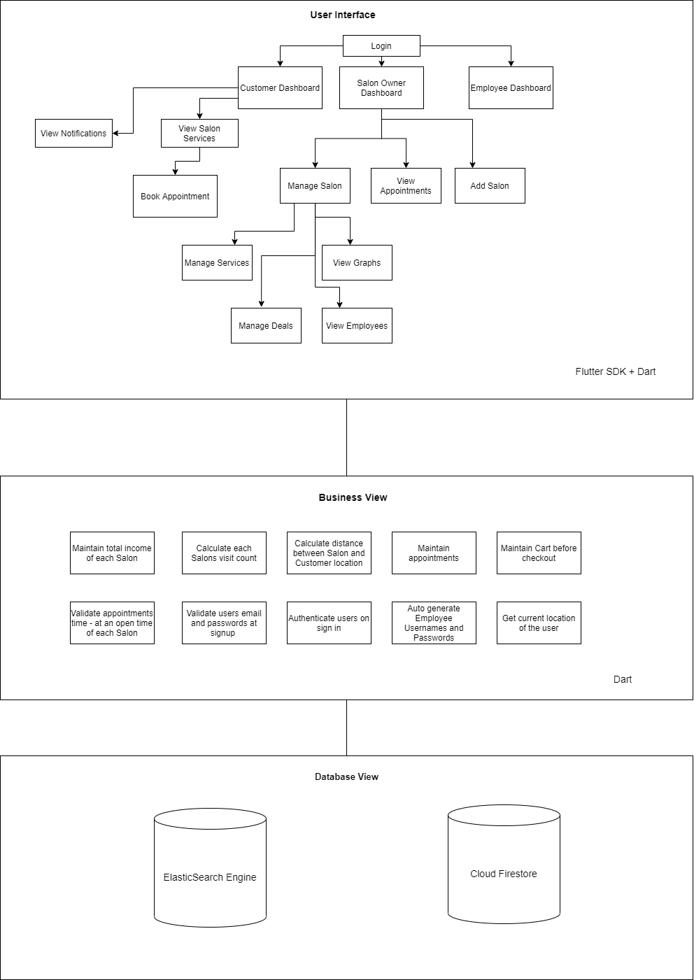

## Box and Line Diagram

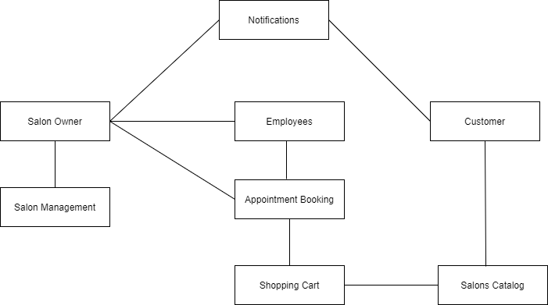

## Rationale

The Component based architecture is considered a good approach due to the reduced time and development cost by reusing existing elements and more reliability with reused components. It provides a hybrid approach between layered and feature-based architecture.

In a CBA, a single component contains the view, business logic and database logic encapsulated together. This provides reusable elements/modules which make the development smoother. With respect to Scissors and Razors, the component based architecture allowed us to develop related functionality as well as interface at the same time. Moreover, it allowed us to create reusable components such as the login page, alert box, and calendar among several others which can be reused not just in this project but also in other management systems. This also ensures reliability of the final product since these individual components have been thoroughly tested.

Within each component the Model View Controller Architecture is most suitable for our project. Since it keeps display and data separate it allows us to make changes in either one of the layers without it affecting the other. It also allows multiple views for a model to allow different users to view the same data but with different levels of access/UI. Moreover, it also supports an asynchronous technique that allows developers to load an application swiftly, allowing a better user experience.

However, one major limitation to using the component based architecture is that there is a very extensive process of identifying all possible requirements of a component which may or may not be ambiguous. In the case of ambiguous requirements there is a possibility of extensive rework, thus limiting the reusability of the component. In the case of MVC architecture, the individual development of UI, Business logic and Controllers, can lead to delay in the overall modules development.

## Code Representation

**Model Class**

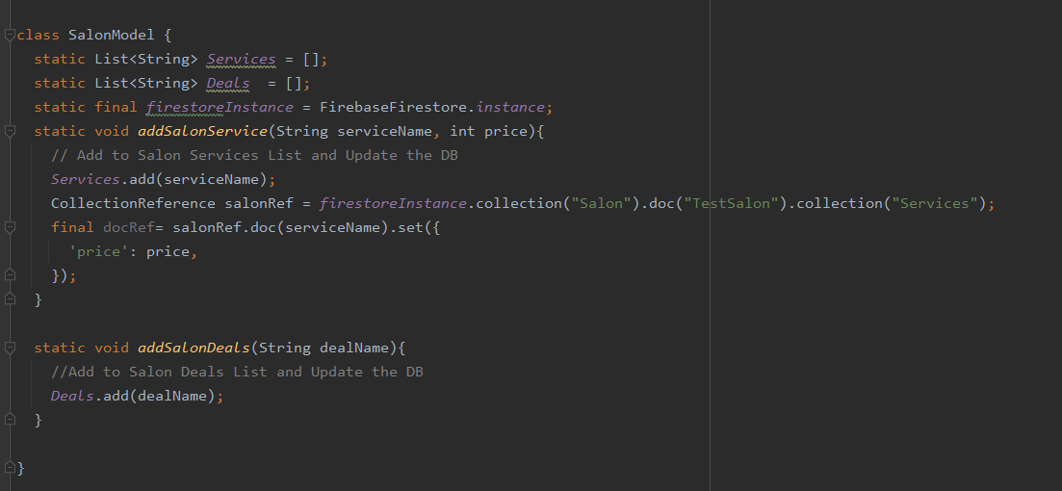

**Controller Class**

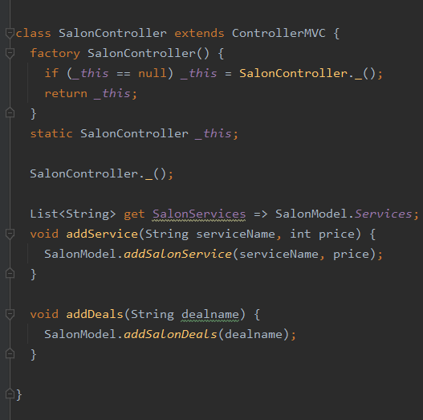

**View Class**

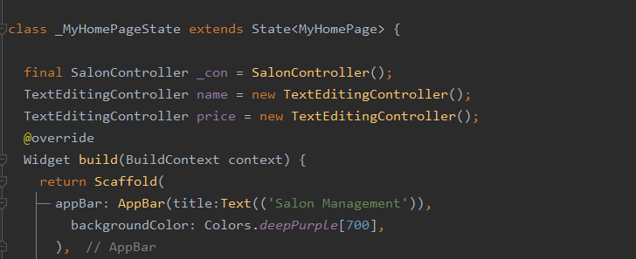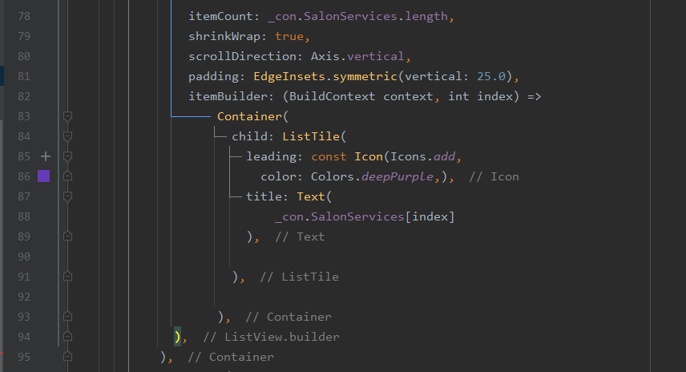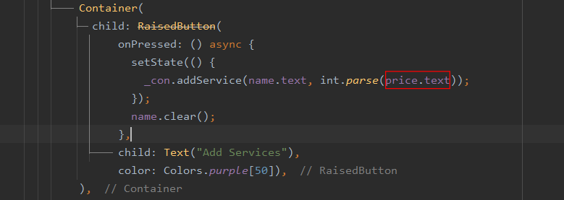

**Output:**

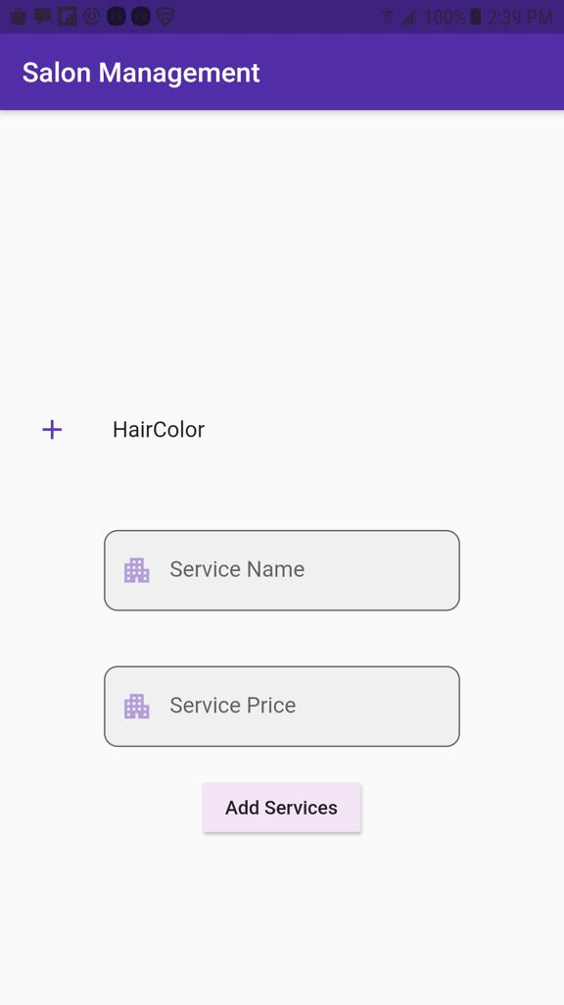

# Screenshots of Trello Board

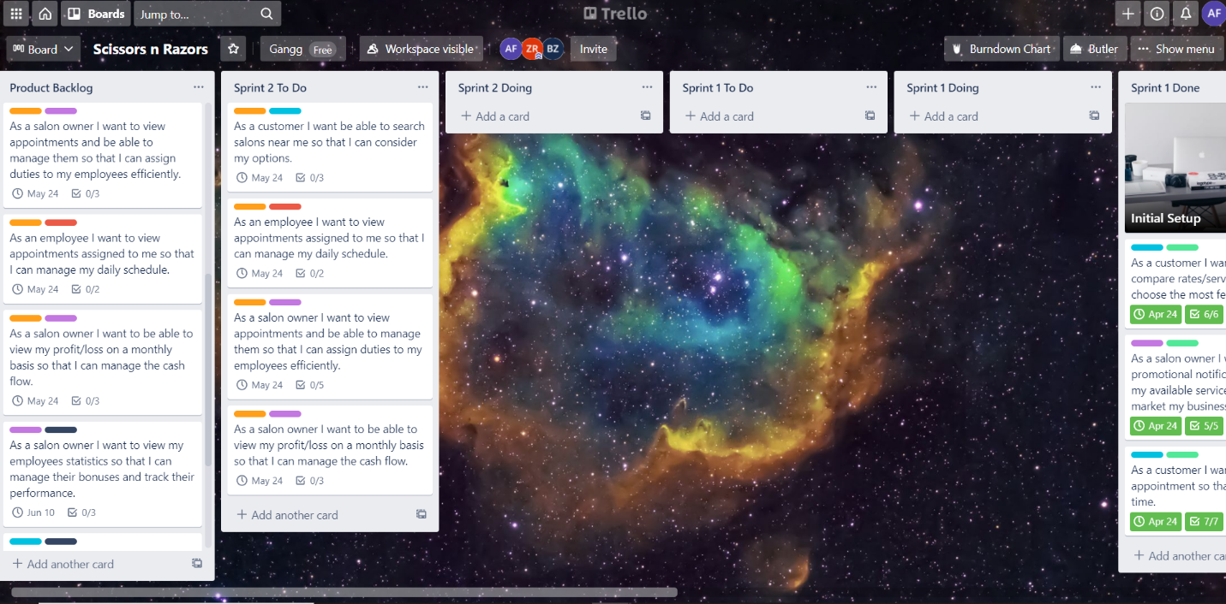

Screenshot

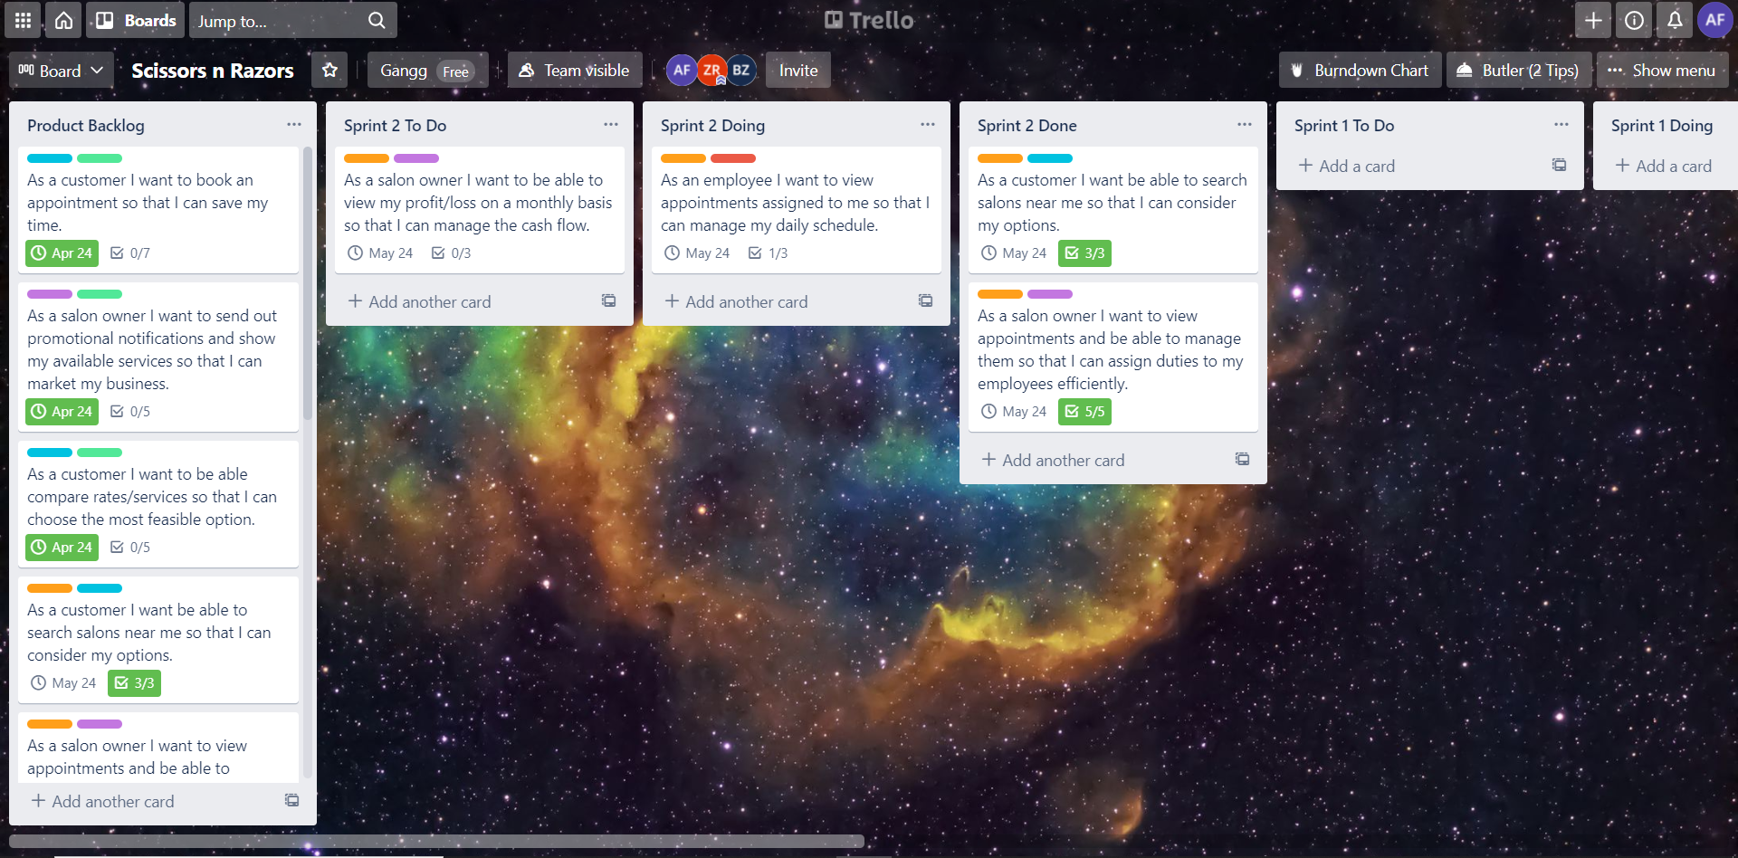

Screenshot

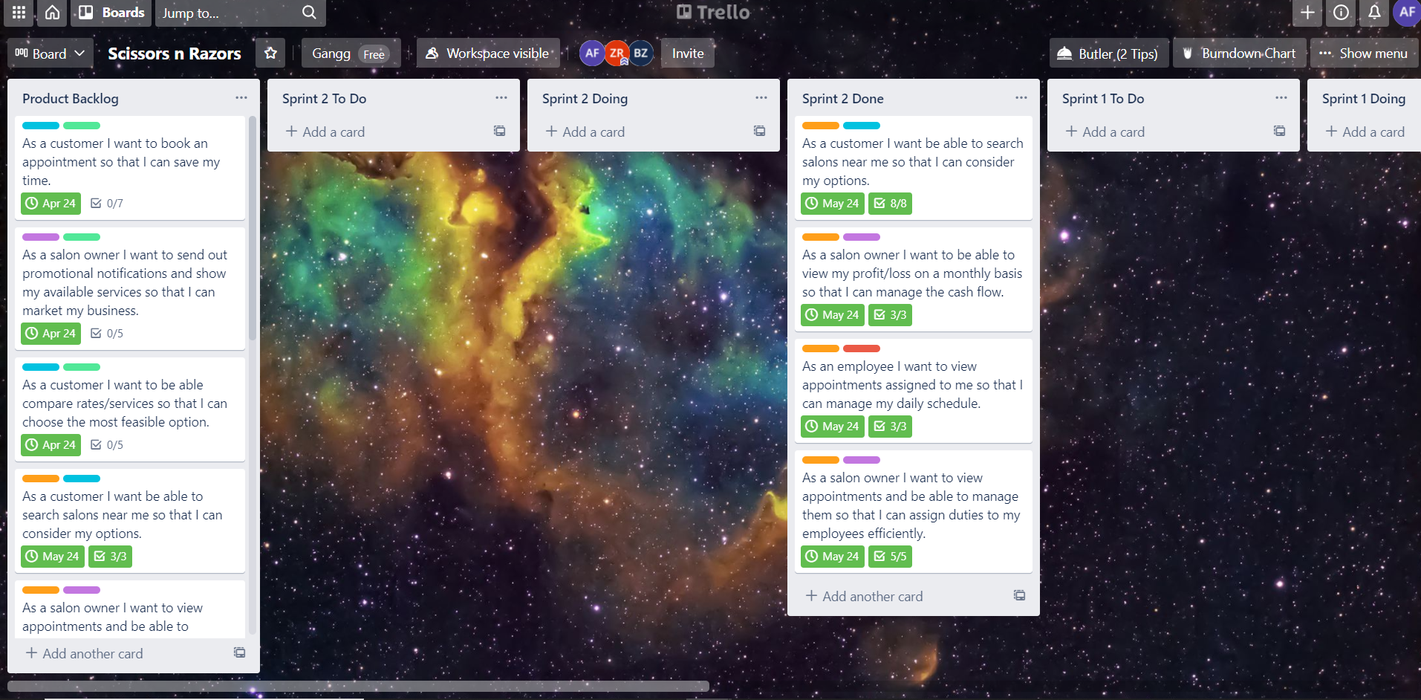

Screenshot

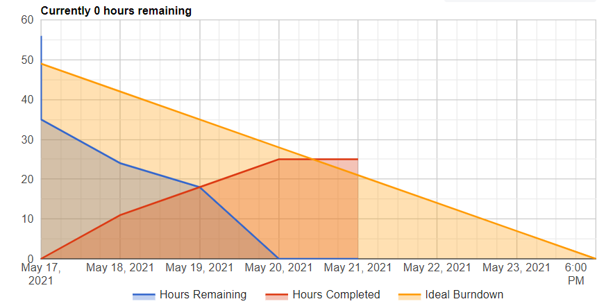

Burdown Chart

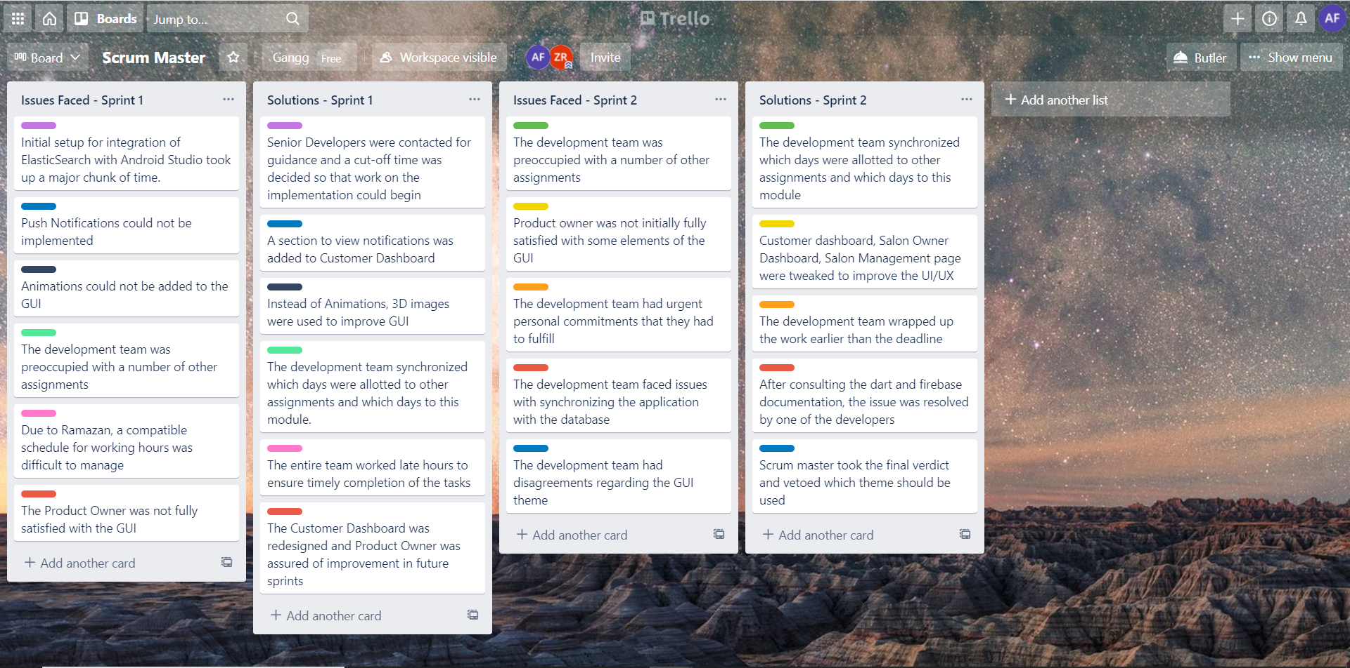

Screenshot

# Leftover Tasks

There were no leftover tasks from Sprint 2